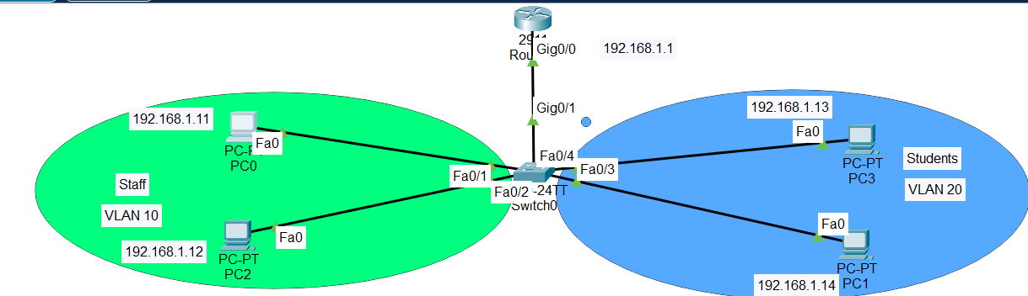

On Router
R1(config-if)#hostname R1
int g0/0
R1(config-if)#ip add
R1(config-if)#ip address 192.168.1.1 255.255.255.0
R1(config-if)#no shutdown

On Switch
Switch(config)#hostname SW1
SW1(config)#vlan 10
SW1(config-vlan)#name Staff
SW1(config-vlan)#vlan 20
SW1(config-vlan)#name Students
SW1(config-vlan)#exit

SW1(config)#int range f0/1-2
SW1(config-if-range)#switchport mode access
SW1(config-if-range)#switchport access vlan 10

SW1(config)#int range f0/3-4
SW1(config-if-range)#switchport mode access
SW1(config-if-range)#switchport access vlan 20

On PC
PC01 192.168.1.11/24
PC02 192.168.1.12/24
PC03 192.168.1.13/24
PC04 192.168.1.14/24

Answer
- 40. What device connects different IP networks?
- Answer:
- A router connects different IP networks.
- 41. Why is segmentation useful?
- Answer:
- Segmentation separates users and devices into different networks, which improves security, reduces unnecessary traffic, and makes network management easier.

